Software Testing Assignment
Module-1
Q-1 What is SDLC ?
Ans. SDLC is a structure imposed on the development of a software product that defines the process for planning, implementation, testing, documentation, deployment, and ongoing maintenance and support.
Q-2 What is software testing?
Ans. Software Testing is a process used to identify the correctness, Completeness, and quality of developed computer software.
Q-3 What is agile methodology?
Ans.Agile SDLC model is a combination of iterative and incremental process models with focus on process adaptability and customer satisfaction by rapid delivery of working software product.
Q-4 What is SRS ?
Ans. A software requirements specification (SRS) is a complete description of the behavior of the system to be developed.
Q-5 What is oops ?
Ans. Identifying objects and assigning responsibilities to these objects.
• Objects communicate to other objects by sending messages.
• Messages are received by the methods of an object.
• An object is like a black box.
• The internal details are hidden.
• Object is derived from abstract data type.
Q-6 Write Basic Concepts of oops .
Ans.• Object
• Class
• Encapsulation
• Inheritance
• Polymorphism
• Abstraction

Q-7 What is object?
Ans. An object represents an individual, identifiable item, unit, or entity, either real or abstract, with a well-defined role in the problem domain.
Q-8 What is class?
Ans. Class is a collection of data member and member function with its behaviour.
Q-9 What is encapsulation?
Ans. Encapsulation is the practice of including in an object everything it needs hidden from other objects. The internal state is usually not accessible by other objects.
Q-10 What is inheritance?
Ans. Inheritance means that one class inherits the characteristics of another class.
Q-11 What is polymorphism?
Ans. Polymorphism means “having many forms”. It allows different objects to respond to the same message in different ways, the response specific to the type of the object.
Q-12 Draw Usecase on online bill payment system (paytm)
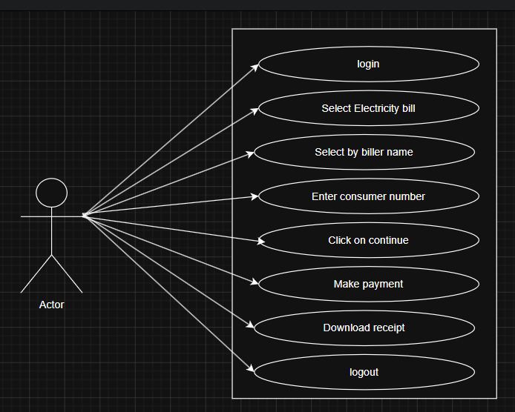
Q-13 Draw Usecase on Broadcasting System.
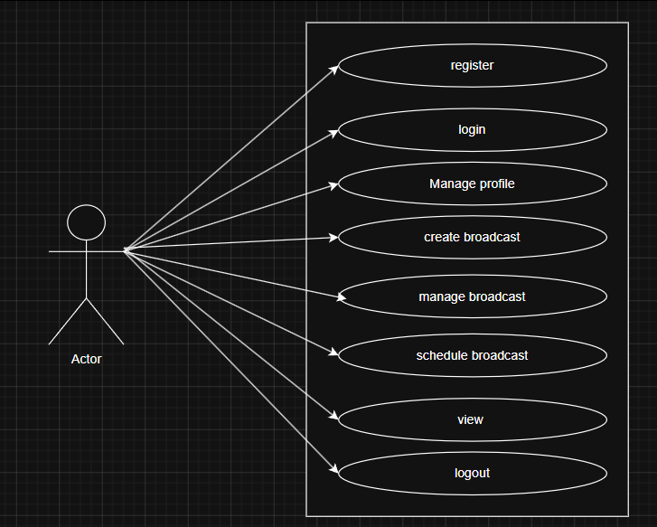

Q-14 Write SDLC phases with basic introduction.
- Requirement gathering:- establish customer needs.
- Analysis:- The analysis phase defines the requirements of the system, independent of how these requirements will be accomplished.
- Design:- Design Architecture Document , Implementation Plan
- Implementation:- The implementation phase deals with issues of quality, performance, Baselines, libraries, and debugging.
- Testing, Maintenance:- Simply stated, quality is very important. Many companies have not learned that quality is important and deliver more claimed functionality but at a lower quality level.
Q-15 Explain Phases of the waterfall model.
- Requirement Analysis,
- System Design
- Implementation
- Testing
- Deployment
- Maintenance.
Q-16 Write phases of spiral model.
- Planning
- Risk Analysis
- Engineering
- Evaluation
Q-17 Write agile manifesto principles.
- Individuals and interactions.
- Working software
- Customer collaboration
- Responding to change.
Q-18 Explain working methodology of agile model and also write pros and cons.
Pros:
- Is a very realistic approach to software development
• Functionality can be developed rapidly and demonstrated.
Cons.
- Not suitable for handling complex dependencies.
- More risk of sustainability, maintainability and extensibility.
Q-19 Draw usecase on OTT Platform.
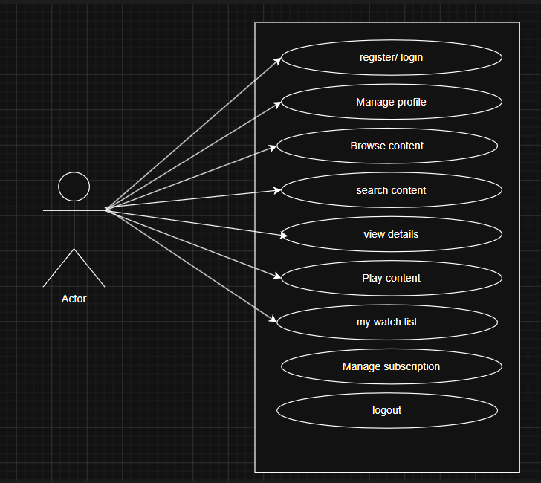
Q-20 Draw usecase on E-commerce application
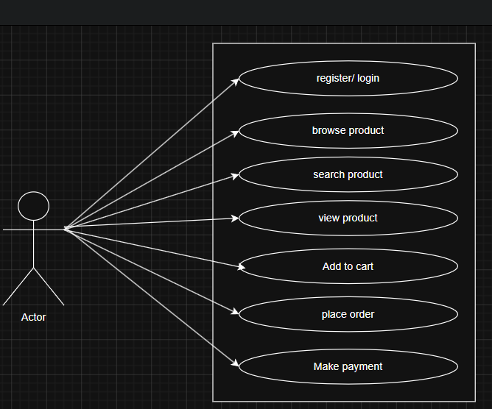
Q-21 Draw usecase on Online shopping product using payment gateway.
